10/1/2026
LAB NO 03
Operating System Lab
Instructor: Ms. Muneeba Banaras
Submitted By: Wasif Ali
Reg ID: 245187
Class: BSCS F’24 B

LAB TASK
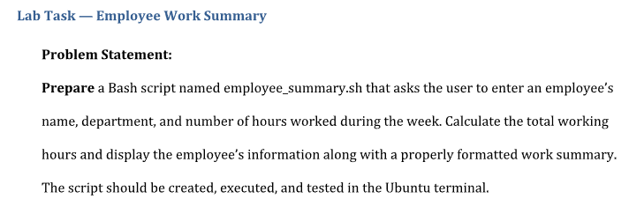

Task Description
- Objective: To write, execute, and test a Bash script in an Ubuntu terminal environment that handles interactive user input, performs multi-variable arithmetic expansion, and outputs a formatted summary card.
- Implementation:
  - Define /bin/bash as the script interpreter on the first line using the shebang construct (#!/bin/bash).
  - Use the read command to capture standard input from the user for text strings (name, department) and integers (hours worked).
  - Store inputs into variables following Bash syntax standards (no spaces surrounding the assignment = operator).
  - Apply Bash integer arithmetic expansion $(( ... )) to aggregate the total weekly hours.
  - Present a structured summary block to standard output using echo statements.

employee_summary.sh
Script File (Shell Script Code):
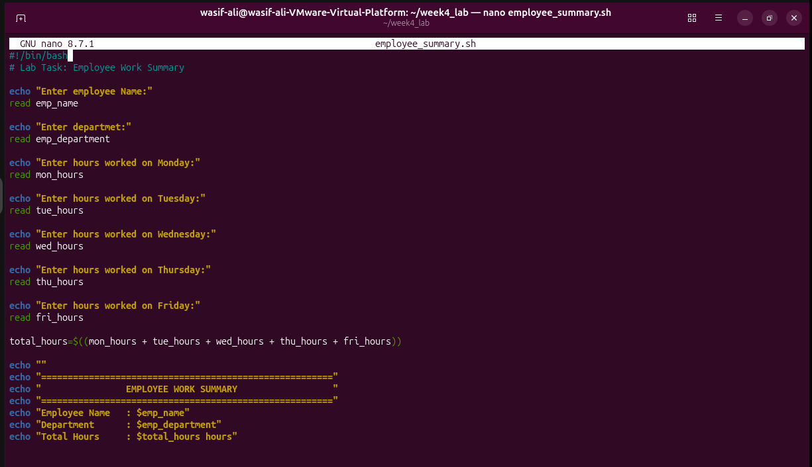
Commands:
